|  |
| --- |
| **Objective A: Investigating** |

|  |  |
| --- | --- |
| **Goal and Global Context**  a). Choose a Global Context  b). Define a goal which is both clear and highly challenging. | 1. GC: Scientific and Technical Innovation 2. To refine my knowledge on C++ by creating a user interface that is easy to use and intuitive, while also creating a piece of hardware that is elegant and functional. The challenging aspect of this goal would be to make the product refined and worthy of presentation. This is a personal challenge for me because I am usually not very precise or especially neat with anything that requires woodwork or other crafting skills. |

|  |  |  |
| --- | --- | --- |
| b). Define a goal which is both clear and highly challenging.  **SMART Goals** | **Specific:**  1).**Who** will be involved, besides you?  2). **What** do you plan to achieve?  **3). When** and **where** do you plan to complete your project?  4). **Why** this particular goal? What is your personal motivation? | 1. Since this project relies on very menial skills that I either already possess, or can acquire with minimal effort, I will not need the help of anyone else, besides the financial support of my father and the support of my supervisor. 2. I hope to have a working smart mirror at the end, with an easy-to-use, user-friendly and intuitive interface. 3. The majority of my project will be completed during my free time at home, I will start work on the physical product sometime after the 25th of October. 4. One personal motivation I have is just to develop skills I don’t already possess, while refining and improving those I do already have. |

|  |  |  |
| --- | --- | --- |
| **SMART Goals** | **Measurable:**  **Your goal must be measurable-** Include precise amounts, dates, and so on in your goals so you can measure your degree of success. ... | According to my action plan, I should have my product fully tested and completed by the start of December. Therefore, I must manage my time effectively, I have already done this via my action plan. |

|  |  |  |
| --- | --- | --- |
| **SMART Goals** | **Achievable:**  Your goal should be achievable within the time frame you have, whilst still presenting the appropriate level of challenge. By setting realistic yet **challenging** goals, you hit the balance you need. | My goal is achievable because although I do not currently possess all of the skills necessary t present a quality product, I do have access to any and all resources I will need, which should allow me to develop any skills I need without any issues. |

|  |  |  |
| --- | --- | --- |
| **SMART Goals** | **Relevant:**  Your goal should be relevant-to the project objectives, to your own interests and to your chosen global context. | Since a large portion of my project relies on my knowledge and understanding of the C++ programming language, refining my knowledge of it should greatly increase the quality of my finished product. |

|  |  |  |
| --- | --- | --- |
| **SMART Goals** | **Timely:**  Your goal should have a clear time limit. This will help you in terms of time management.  **Deadlines.** | My project should be fully completed and I should be able to start my report by December 9th. My physical product should be completed by the end of November, the remainder of the time should be used to test my product and make any necessary adjustments, or add any finishing touches. |

|  |  |
| --- | --- |
|  |  |

|  |  |
| --- | --- |
| c) Describe what makes their project personal? | This project is personal to me because not only does it requires skills that I already possess and am comfortable with, but it also requires skills on the other end of the spectrum, skills that are not as refined and I rarely use. In addition to this, my personal project is actually something that I might enjoy doing. |

|  |  |
| --- | --- |
| **Prior learning and subject-specific knowledge**  The prior learning and subject knowledge referenced by the student must be consistently highly relevant. | My knowledge of C++ is something that I will rely on when creating my product, it is specific to I.C.T (Design). I already have sufficient prior knowledge of C++ to successfully create my smart mirror, however I will still try to brush-up on some C++ to ensure that my final product is as expurgated of any issues or bugs that may arise during development, as possible. |

|  |  |
| --- | --- |
| **Research Skills ATL**  a). Have conducted research which is systematic and effective to the project and shows insightful understanding of perspectives.  b) Document information fully and correctly using a recognized referencing convention.  c) Will use a minimum of 10 sources, ideally a minimum of 20. | OPLV-Create a chart to evaluate sources. See **Resource 3**  You can choose your own format.  ***(In separate document)*** |

|  |  |
| --- | --- |
| * **Collect and record data/sources- Lower Challenge Level** * **Identify primary and secondary sources- Lower Challenge Level**   **Low** | * **Locate, organise, analyse, evaluate and ethically use information from a variety of sources and media- Higher Challenge Level** * **Use critical literacy skills to analyse and interpret information-Higher Challenge Level** |

|  |  |
| --- | --- |
| **Completed -Date 17/10/2018** | **Supervisor signed:** |

|  |
| --- |
| **Objective B: Planning** |

|  |  |
| --- | --- |
| **Develop criteria for the product/outcome**  a).**Develop rigorous criteria** for the product/outcome which can be easily evaluated by someone unfamiliar with the product.  b) Refer to the criteria they designed to evaluate the project product/outcome.  c) Explain any changes made and why they made them.  **Resource 4** | **Create a specification chart (see example below) align it with the assessment criteria**  **See the chart -exemplar Uptown** |

|  |  |  |  |  |
| --- | --- | --- | --- | --- |
|  | **Aesthetics** | **Function** | **User Friendliness** | **Costs** |
| **7-8** | The product looks like an ordinary mirror when it is powered off. When it is powered on there is no backlight ‘bleed’ and all UI elements are clear. | The mirror displays any and all useful information the user may want, like time, weather, a news feed and more. It is fully customizable/modular and does not clutter the view in any way. | The product can be used and customized by anyone from any age group with little to no effort. The language of the user interface can also be changed. | The product only costs around 600 AED to build, inclusive of shipping charges and does not compromise any quality for the lower price. |
| **5-6** | The product almost looks like an ordinary mirror when it is powered off. When it is powered on there is very little backlight ‘bleed’ and all UI elements are fairly clear to the point where they are legible. | The mirror displays many widgets with useful information the user may want, like time, weather, a news feed and more. It is customizable/modular to an extent and does not clutter the view that much. | The product can be used and customized by most people aged 12-50 with some effort. The language of the user interface can also be changed. | The product costs around 800 AED to build, inclusive of shipping charges and does not compromise any quality for the lower price. |
| **3-4** | The product resembles an ordinary mirror when it is powered off. When it is powered on there is some backlight ‘bleed’ and the UI elements are somewhat legible. | The mirror displays some widgets with useful information the user may want, like time, weather, a news feed and more. It is barely customizable/modular and can sometimes clutter the view. | The product can be used and customized by some people aged 18-50 with an adequate amount of effort. The language of the user interface cannot be changed. | The product costs around 1000 AED to build, inclusive of shipping charges. The price is somewhat justifiable by the overall quality of the product. |
| **1-2** | The product does not look like a mirror, when it is powered on it is not possible to read or see any of the UI elements. | The mirror displays no widgets with useful information the user may want, like time, weather, a news feed and more. It is not customizable/modular and almost always clutters the view. | The product is barely usable and cannot be customized in any way. The language of the user interface cannot be changed. | The product costs more than 1000 AED to build, inclusive of shipping charges. The high price is not reflected at all by the overall quality of the product. |

|  |  |
| --- | --- |
| **The planning and recording of the development process of the project.**  a) Present **a detailed and accurate plan** and record of the development process of the project from start to finish.  b) Provide evidence of planning through **timelines, milestones or other tools/strategies** (in the appendices).  **Resources 5** | **Action Plan:** |

**Visual Timeline: (https://i.imgur.com/F5R8Xmj.jpg)**

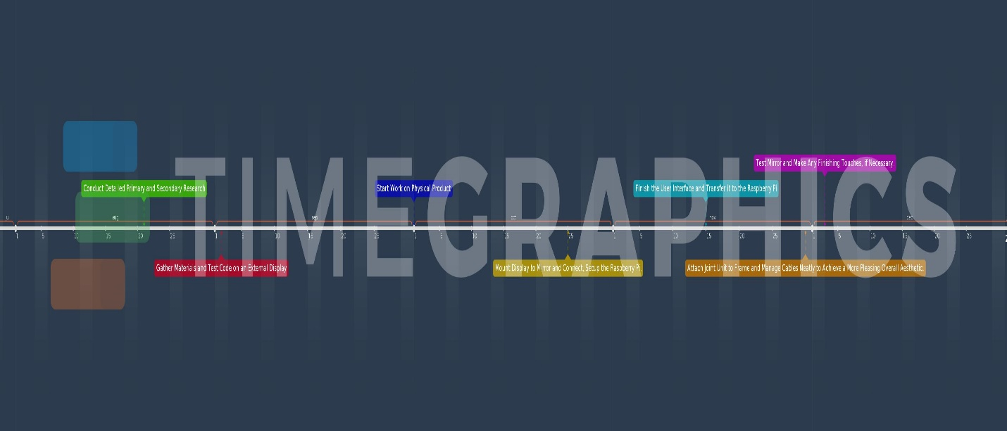

|  |  |
| --- | --- |
| **Self-management skills. ATL**  a) Outline the self-management skills they had when they started the project.  For example a **Gantt Chart, Scrum board/ -Resource 1 folder examples**    b) Have demonstrated to you that they have outstanding organization and time management skills.  c) Show how self-awareness of strengths and limitations guides effective planning and helped them complete their project.  d) Discuss the self-management skills they developed through the project. **For example a compass point visible thinking chart-See Resource 2 examples** | **Work Done Per Week (Up till now):**    **Choosing a User Interface:** |

|  |  |
| --- | --- |
| * Keep a basic log or timeline planning for the project **Lower Challenge Level** * Keep an organised and logical system of information **Lower Challenge Level**   **Low** | * Make plans that are logically sequential and efficient **Higher Challenge Level** * Demonstrate persistence and perseverance **Higher Challenge Level** * Practise ‘bouncing back’ after adversity (struggling, difficulties), mistakes and failures **Higher Challenge Level** |

|  |  |
| --- | --- |
| **Completed -Date**  **28/10/2018** | **Supervisor signed:** |

|  |  |
| --- | --- |
| **Objective C: Taking**  **Action** |  |

|  |  |
| --- | --- |
| **Creation of product/outcome in response to the goal, global context and criteria.**    a) Discuss the product/outcome as the result of the process undertaken during the project. How is my product/outcome reflecting the global context chosen?  Ask others:   * Is the chosen **global context** evident in my product/outcome? * From viewing my work, can you (another person, looking at it) develop a different or deeper understanding of the **global context** chosen? * Document in journal   b) Have included evidence of the product in the report. |  |

|  |  |
| --- | --- |
| **Thinking skills ATL**  a) Demonstrate how their conceptual understanding and contextual learning have influenced the development of the project.  b) Outline the thinking skills they had when they started the project.  c) Discuss the thinking skills they developed through the project.  d) Explain how they may have shared thinking skills to help peers who needed more practice. | 1). What obstacles have you encountered?  2). How have you overcome problems through problem solving?  3). How have you generated novel ideas and considered new perspectives?  4). How have you made connections between what you already knew to what you are learning in the process of taking action?  How have you taken feedback on board and added this into the creation of your product/outcome?  5). How have you developed flexible thinking strategies surrounding the ethical impact of your product outcome?  How have you employed your prior learning in the creation of your product outcome?  6). How have you used your subject specific knowledge and skills in multiple contexts?  What new insight do you have into your chosen global context? ***I used to think...but now I think...and this is why…*** |

|  |  |
| --- | --- |
| * Identify problems **Lower Challenge Level** * Present one perspective   **Lower Challenge Level**   * Draw simple conclusions **Lower Challenge Level** | * Consider multiple alternatives, including those that might be unlikely or impossible **Higher Challenge Level** * Make guesses, ask ‘what if?’ questions **Higher Challenge Level** * Create novel solutions to complex problems * **Higher Challenge Level** * Combine knowledge, understanding and skills to create products or solutions **Higher Challenge Level** |

|  |  |
| --- | --- |
| **.Communication and social skills** **ATL**  a) Outline the communication and social skills they had when they started the project.  b) Demonstrate how their interactions with others, through clear and consistent communication, builds a sense of community in the development of the project.  c) Demonstrate understanding of perspective, interpretation and empathy, and effectively transfers this knowledge to his or her own communication strategies.  d) Discuss the communication and social skills that developed through the project | 1). How have you managed to resolve conflict and work collaboratively with others?  2). How have you encouraged others to contribute to your personal project?  3). How have you worked effectively with your supervisor and taken their ideas and advice on board?  **Could this be turned into a chart?**  Visible thinking -What makes you think that? **Create a chart**  **Ladder of feedback chart** |

|  |  |
| --- | --- |
| Organise information **Lower Challenge Level**  Structure report following advice **Lower Challenge Level** | Work effectively with the supervisor, act meaningfully on feedback received **Higher Challenge Level**  Share ideas, collaborate and build relationships with peers and experts using a variety of digital environments and media **Higher Challenge Level** |

|  |  |
| --- | --- |
| **Completed -Date**  **11/11/2018** | **Supervisor signed:** |

|  |
| --- |
| **Objective D: Reflecting** |

|  |  |
| --- | --- |
| **Evaluation of the quality of the product/outcome against their criteria.**  a) Evaluate the product/outcome against the criteria they designed.  b) Identify the strengths, weaknesses and possible improvements of the product/outcome.  c) Have made use of primary data collected for the purpose of objectively evaluating the quality of the product, where relevant. |  |

|  |  |
| --- | --- |
| **Reflection on how completing the project has extended their knowledge and understanding of the topic and the Global Context.**  a) identify challenges and the solutions developed to meet them.  b) Demonstrate a deeper knowledge and understanding of the topic and the identified **global context.**  c) Base reflections on evidence, including references to specific process journal entries. |  |

|  |  |
| --- | --- |
| **Reflection on their development as IB learners through the project.**  a) Present a reflection on how completing the project has extended his or her knowledge and understanding of the topic and the **Global Context.**  b) Make reference to several **IB Learner Profile traits** and how they feel these have developed through completing the project. |  |

|  |  |
| --- | --- |
| **Completed -Date** | **Supervisor signed:** |